**23 Nov 2018** **The Weekly Bulletin of Rotary Club of Kathmandu Mid-Town** **bc-10.11/018**

|  |
| --- |
| C:\Users\Public\Documents\RIP T1819_EN.png |

District: 3292 Web:www.rotarymidtown.org.np Club Id: 26776

**NOVEMBER IS ROTARY FOUNDATION** **MONTH**

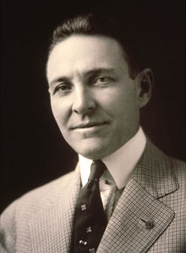

As an officer of RI, the governor has direct responsibility for promoting The Rotary

Foundation within the district, to the end that the aims and purposes of the Foundation

in furthering world understanding and peace may become better known and supported.

Participation in Foundation programs is an important part of the Foundation’s success.

To allow districts a voice in how contributions are spent and the fullest possible

participation, the Trustees developed the SHARE system for the allocation of funds.

All district Annual Fund SHARE contributions are divided into two categories: District

Designated Fund (DDF) and World Fund. The distribution between these two funds is

50 percent to DDF and 50 percent to the World Fund. Contributions made in a given

year will be eligible to be spent three years later. PRI P Arch C. Klumph

The district may use its DDF for district grants, global grants, Rotary Peace Fellowships and donations to PolioPlus. The World Fund supports other Foundation activities such as PolioPlus, Rotary Peace Centers, the Foundation match of global grants, packaged grants, and other Foundation programs as determined by the Trustees.

**Club Meeting # 1464** : 16 Nov 018

Club’s Charter Night Celebration

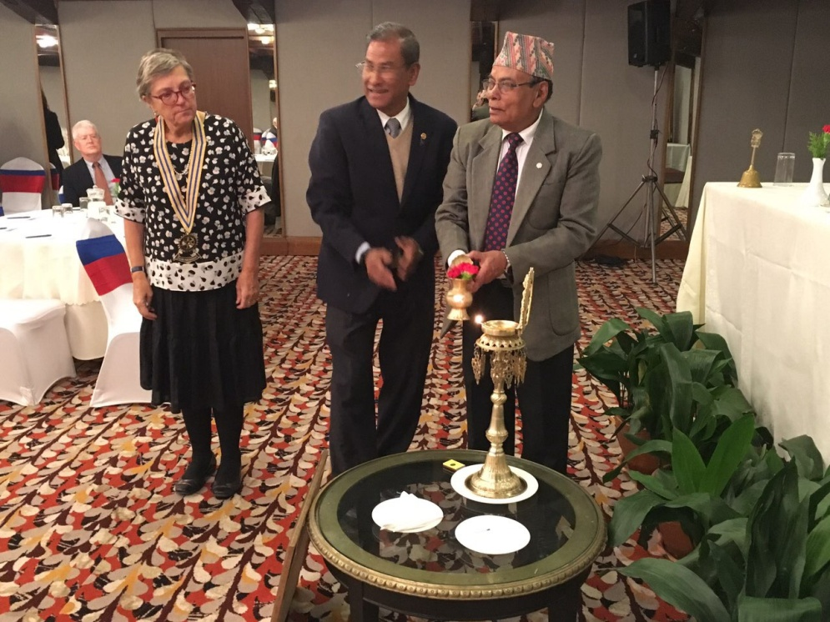 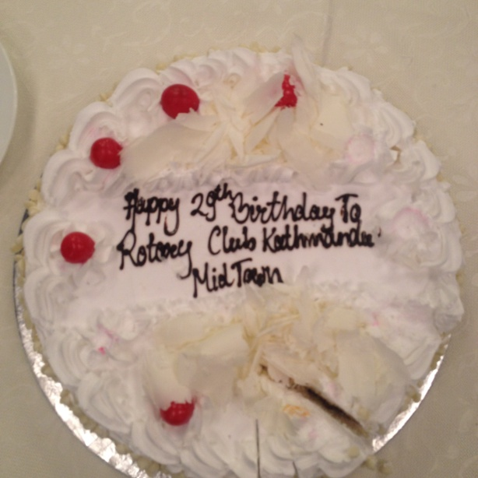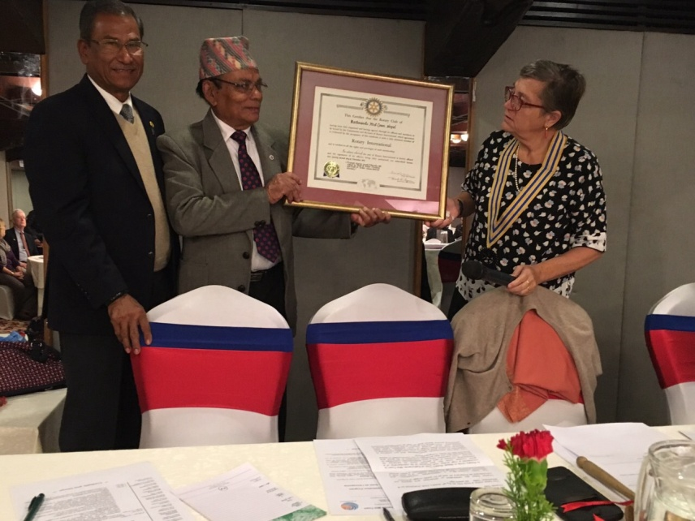

PDG Yogendra Pradhan and AG Bijaya Mallapaty Birthday cake PDG Yogendra handing over the Charter

lighting the *Panas* together for celebration to start. Certificate to President Jo

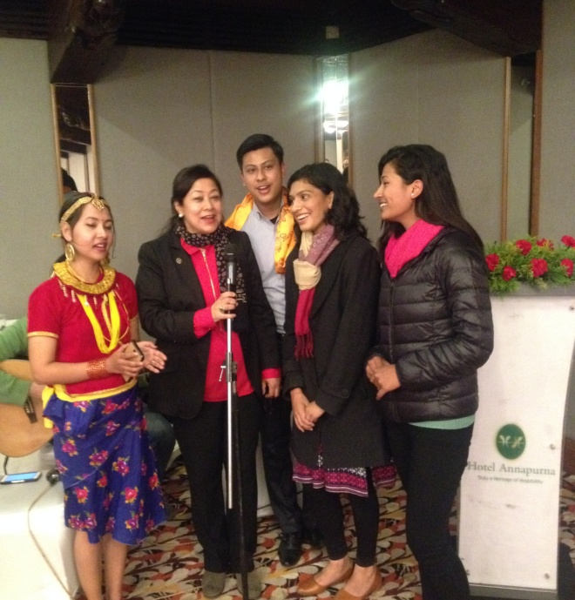 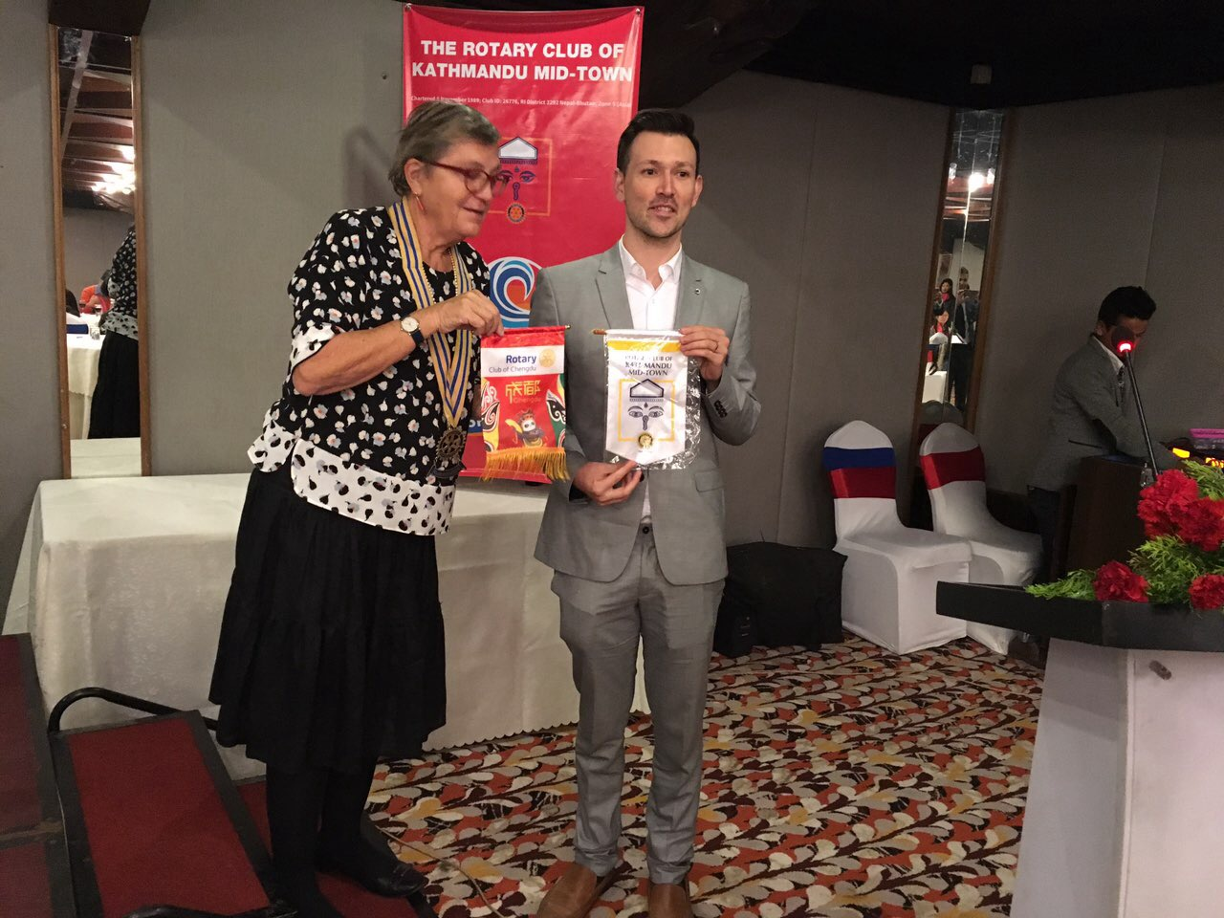

PE Neeva M Pradhan singing with Rotaracts President Jo exchanging banners with visiting Rotarian

*Photo courtesy: Rtn Shyam R Thapalia*.

# Weekly Meeting/Program Schedule:

|  |  |  |
| --- | --- | --- |
| Date | Program/ Speaker | Topic of Presentation |
| 30 Nov 2018 | Shiraz and Samiksha | How to get the most out of your Facebook account |
| 7 Dec 2018 | Club Assembly |  |
| 12 Dec 2018 | DG Visit |  |
|  |  |  |

Friday Meeting: 23 Nov

Dr Neil Pande will talk on ‘whats going on in the world of dentistry’.

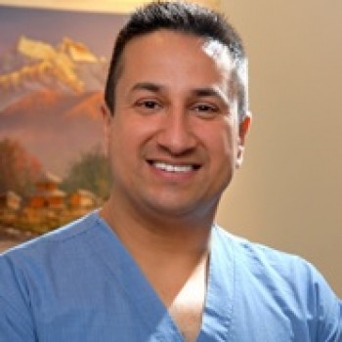

He graduated from Manipal in 1996, completed his MFGDP and MFDS from Royal

College of Surgeons of England in the year 2004 and 2006 respectively. He has served

as a General Secretary of Nepal Dental Association, President of Centre for Continuing

Dental Education and Research, Co-ordinator for the Royal College programs as well as

Progressive Orthodontics USA. He also has served in Toastmaster Club as a President.

Currently, he is the Founding President of Nepalese Society of Implant Dentistry and

President of Academy of Dentistry International - Nepal Chapter.  His current focus is on Guided Implantology and CAD/CAM. He strongly believes in preventive dentistry, holistic care and minimally invasive practices. He has been a Rotarian in Kathmandu Mid-Town.

**AWON Christmas Bazar:**

 

*Source: Rtn Isabella Khadka*

**Committee Chairs’ Column:** *(This column is for use by chairpersons of 5 permanent committees: Club Administration, Membership, Public Relations, Service Projects, and the Rotary Foundation)*

**Members’ Corner:** *(This column is for Club members to express anything they would like in matter of Club activities, Club administration, Club issues or on Breakfast Chatter, or on anything else that would be of interest to fellow members.)*

**Walkers’ Circle:**

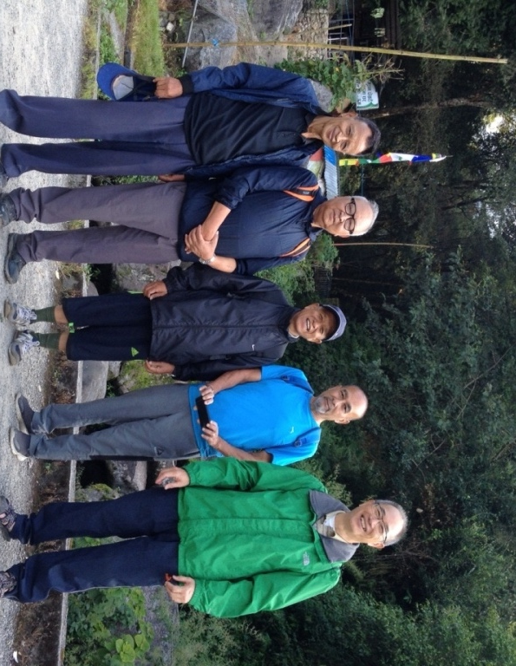 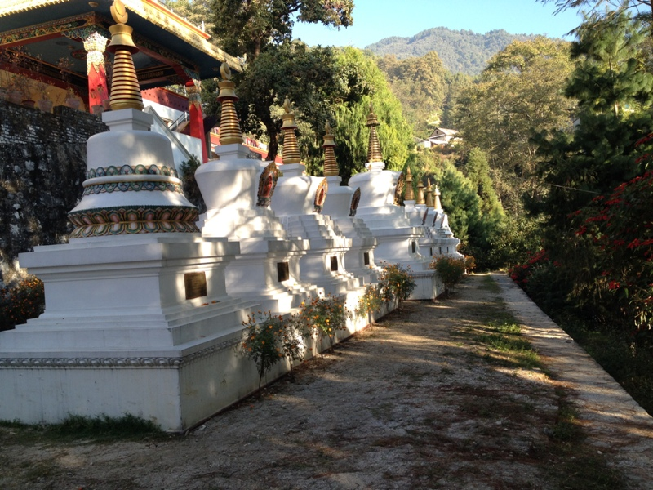

RCKMT walkers at near Bipasanna Centre, Shivapuri Temples at a Monastery near Budhanilkantha

**Do you know?**

Every minute of every day someone’s life is being improved by our Rotary Foundation. Rotary clubs on every continent are working to improve the living conditions and health of their fellow citizens. Rotarians like you and me can make a difference by continually supporting our Foundation and the Annual Fund. As Rotarians we determine where funds are allocated through District Designated Funds, which we can use for local or international projects. When we contribute to our Foundation we are promoting worldwide Peace and Understanding.

Only if Every Rotarian Every Year makes a gift to the Annual Fund we will be able to continue to do the great work of The Rotary Foundation.

*Source: TRF Weekly Thoughts*

**PACT: Participation, Acknowledgement, Commitment, and Transformation**

**Turning teens away from crime:**

Rotary clubs in Canada invest in the PACT program, an urban peace initiative that aims to break the cycle of youth crime. PACT is a Toronto-based, award-winning charity supported by Rotary clubs in Canada. It works with at-risk young people and those who have committed crimes to change their direction in life. Entrepreneur and Toronto Rotary member David Lockett co-founded the program more than 20 years ago.

The intensive, step-by-step program aims to break the cycle of poverty and criminal behavior. Its goal is to determine what the participants need and develop strategies “to put them on a positive path in their life, so they can enrich not only their own lives, but their community,” says Lockett, a member of the Rotary E-Club of Social Innovators D7090.

Lockett says PACT builds peace in urban communities. “It’s all about looking at the impact of violence and criminal behavior, and understanding the dynamics of the problem, and creating highly effective solutions to make investments for at-risk youth at an early stage,” he says. “It’s really quite simple. If you want to help at-risk youth, you really have to understand the simple needs they have.”

To date, nearly 30 clubs in the Toronto area have supported PACT, many with annual commitments of $3,600 or more to fund the program, according to Lockett.

visit: *https://www.rotary.org/en/rotary-clubs-help-youth-turn-away-crime*

**A THOUGHT FOR TODAY:**

**Seven blunders of the world that lead to violence:**

**Wealth without work, Pleasure without conscience, Knowledge without character,**

**Commerce without morality, Science without humanity, Worship without sacrifice,**

**Politics without principle.** - Mahatma Gandhi

*Courtesy: Rtn Dr Isabella Khadka*

On Lighter Side:

Two boys went into a restaurant and asked for two cups of coffee.

As soon as the waiter placed two cups of coffee on the table, they took out sandwiches out of their bags and started eating.

"You can't eat your own sandwiches in here," the waiter warned.

They swapped their sandwiches!

To me, as a Bahamian, the sea has always been something special. It represents both distance and

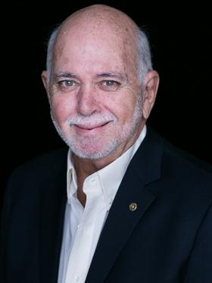

connection…. And that sense of connection, that sense of inspiration, that sense of longing for

something that seems just out of reach but is much closer than we think - I want you to inspire in

your clubs, your Rotarians, that desire for something greater. The drive to do more, to be more, to

create something that will live beyond each of us.

**RI President Barry Rassin**

Please send information on club activities, progress reviews on service projects, relevant photos etc to:

BC Editor: RR Shrestha email: rryesrr@gmail.com

## 23 Nov 2018 The Weekly Bulletin of Rotary Club of Kathmandu Mid-Town bc-10.11/018